Template for SDP20 Final Project Report (put project title here)

First A. Author, EE, Second B. Author, CSE, Third C. Author, EE, and Fourth D. Author, CSE
Abstract—This is an editable template. You should follow the format of this template in writing your SDP MDR report, and the final report. Your abstract goes here and should be one paragraph. This is a version of your problem statement that uses everyday language (avoid technical vocabulary and acronyms) and contains the 3 elements: background; the design; deliverables of the design project.

INTRODUCTION
S
tart with the statement of the problem. What is the problem that you are trying to solve?

Significance
How big is this problem? Include citations that demonstrate that your problem is significant.

Context and Existing Products
Put your problem in context. How have people solved your problem in the past? Has the problem changed with time? Describe at least two products currently available that solve the same problem or a similar problem. What is different about your proposed solution?

Societal Impacts
What are your constituencies? That is, who is impacted by your product, mostly in positive ways, but possibly others in negative ways? How are they impacted? How do these constituencies affect your design choices?

System Requirements and Specifications
Summarize the system-level requirement and their associated specifications and then list the requirements, specifications and values as shown in Table 1.

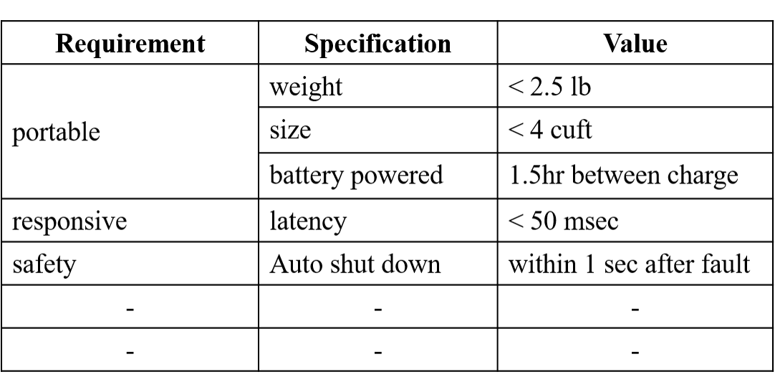
Table 1: Requirements and Specifications

Design

Overview
How did you solve this problem? What technology did you use? Why did you expect that this technology will solve your problem? What other technologies did you consider? Refer to the Appendix (Section A) for more details as needed. Describe how satisfaction of multiple specifications listed in Table 1 imposed tradeoffs on your overall design.
Include a block diagram as a figure and refer to it in the text as in “See the block diagram in Figure 1.” Do this for all figures used in the report. Describe each block (and each arrow) in the diagram. What (sub-system level) specifications do each block meet? How do these sub-system specifications collectively guarantee that the system meet its overall specifications?

Block 1
Describe what this technical block does. Explain what technology you used to build this block. Detail which techniques from courses you used to build this block. List what you learned in order to build this block. Summarize an experiment you performed to design or test this block. Refer to Appendix (Section B) for more information about the experiment as needed.

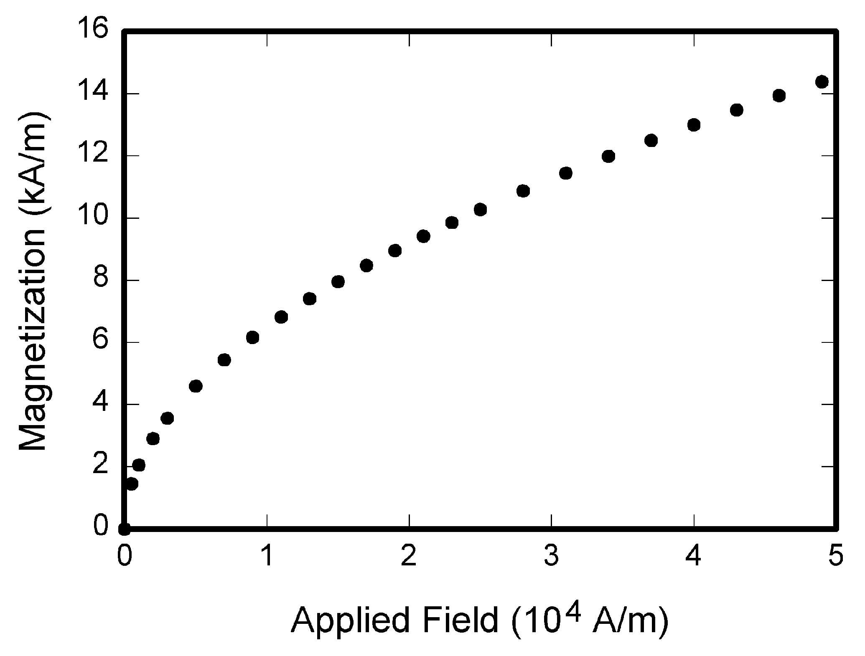
Figure 1:Magnetization as a function of applied field. Note: It is good practice to explain the significance of the figure in the caption.

Block 2
Describe what this technical block does. Explain what technology you used to build this block. Detail which techniques from courses you used to build this block. List what you learned in order to build this block. Summarize an experiment you performed to design or test this block. Refer to Appendix (Section B) for more information about the experiment as needed.

Block 3
Describe what this technical block does. Explain what technology you used to build this block. Detail which techniques from courses you used to build this block. List what you learned in order to build this block. Summarize an experiment you performed to design or test this block. Refer to Appendix (Section B) for more information about the experiment as needed.

Block 4
Describe what this technical block does. Explain what technology you used to build this block. Detail which techniques from courses you used to build this block. List what you learned in order to build this block. Summarize an experiment you performed to design or test this block. Refer to Appendix (Section B) for more information about the experiment as needed.

The Product

A. Overview
Discuss the overall product by including your “Product Sketch” as a figure and connecting the product’s principle features with the block diagram’s subsystems and interfaces. Ensure that the reader understands how the block diagram (the “design”) manifests itself in the product. If available, provide pictures of the product.

B. Electronic Hardware Component
Discuss in detail the design, fabrication, population and testing of your principal electronic hardware component; aka, your principal printed circuit board (PCP). Provide pictures of your final PCB together with pictures of any hand-soldered protoboards.

C. Functionality
Using your block diagram, discuss what elements of your product were functioning and those that were not functioning at time of CDR. Provide evidence that your product worked and discuss the issues faced in troubleshooting the non-functioning elements.

D. Performance
Return to the Requirements and Specifications in Table 1 and discuss your product’s ability to meet requirements by providing data showing that the specifications were satisfied. Discuss why some specifications were not met.

Conclusion
Summarize the state of the project at CDR and describe what your team needed to accomplish by FPR to have a working product meeting specifications.

Acknowledgment
You may not have any acknowledgements, but this is the place you thank anyone that donated equipment or gave you advice on your project.

References
- G. O. Young, “Synthetic structure of industrial plastics (Book style with paper title and editor),” in Plastics, 2nd ed. vol. 3, J. Peters, Ed. New York: McGraw-Hill, 1964, pp. 15–64.
- W.-K. Chen, Linear Networks and Systems (Book style). Belmont, CA: Wadsworth, 1993, pp. 123–135.
- H. Poor, An Introduction to Signal Detection and Estimation. New York: Springer-Verlag, 1985, ch. 4.
- B. Smith, “An approach to graphs of linear forms (Unpublished work style),” unpublished.
- E. H. Miller, “A note on reflector arrays (Periodical style—Accepted for publication),” IEEE Trans. Antennas Propagat., to be published.
- J. Wang, “Fundamentals of erbium-doped fiber amplifiers arrays (Periodical style—Submitted for publication),” IEEE J. Quantum Electron., submitted for publication.
- C. J. Kaufman, Rocky Mountain Research Lab., Boulder, CO, private communication, May 1995.
- Y. Yorozu, M. Hirano, K. Oka, and Y. Tagawa, “Electron spectroscopy studies on magneto-optical media and plastic substrate interfaces (Translation Journals style),” IEEE Transl. J. Magn.Jpn., vol. 2, Aug. 1987, pp. 740–741 [Dig. 9th Annu. Conf. Magnetics Japan, 1982, p. 301].

Appendix
Sections A - D are required appendix sections. You may refer to these materials in the report body as needed. An appendix is a useful catchall when there is too much detail to include in the report body, but where this content is still useful to be communicated. Include such details in Section E, F, … and so on.

Design Alternatives
Describe the design alternatives that you considered before settling on your current design. What criteria did you use to distinguish alternatives? What’s wrong with the alternatives you discarded? Explain how this helped you make design choices.

Technical Standards

A desirable characteristic of product design is to use standardized hardware and software for technical reliability and soundness; e.g., WiFi, Bluetooth and Unix are common standards. Together with numerous worldwide standards associations (for example, FAA, FCC and OSHA), IEEE has their own https://standards.ieee.org/ - a partial listing of IEEE standards are provided at

https://en.wikipedia.org/wiki/IEEE_Standards_Association

To demonstrate your awareness of engineering standards:

Give examples of standardized hardware and software used in your project design.
- For each of these standardized hardware and software examples, describe an underlying IEEE standard that they adhere to.
- Describe any additional standards incorporated in the project (for example, FCC standards for wireless transmission, FAA issues with drones, OSHA standards for audio volume or high voltage, etc.).

Testing Methods
What experiments have you designed and executed so far? What is the purpose of each experiment? Describe each experiment and the methods you used to gather and analyze data. Which block are you testing with each experiment? What conclusions have you drawn from your experiments? Do you need to do further testing?
Describe the experiments you will do to verify that your system meets each of your design specifications.

Team Organization
Describe how your team is organized. Describe how well or poorly the team is working. What is the expertise of each team member? How have you been helping each other out? How is your team communicating with each other? If possible and appropriate… Give an example of when each member provided leadership. Give an example of when each member helped another member. Give an example of when communication within the team broke down and what you did about it.

Beyond the Classroom
Each member should describe the skills they have needed to develop and the knowledge they have needed to learn as a result of this project so far. What resources have been useful to you? Do you see any connections between this and your life as a professional?

Additional Appendix Section

Additional Appendix Section

F. A. Author from Lexington, Ma (e-mail: author@ boulder.nist.gov). S. B. Author, Jr., from Auburn, Ma (e-mail: author@lamar.colostate.edu). T. C. Author from Quincy, Ma (e-mail: author@nrim.go.jp).

